Rhombic Triacontahedron

Definition
# Source: AI Source: Provided by: [Data Path: Persons Table -> ID Column: 1, Name_En Column: Motasem Essam] -> From: [ChatGPT] on [7/25/2026]
A Rhombic Triacontahedron is a convex Catalan solid consisting of 30 congruent rhombic faces, 60 edges, and 32 vertices.
It is the dual polyhedron of the Icosidodecahedron, an Archimedean solid.
Its name describes its structure:
- Rhombic means that its faces are rhombuses.
- Triacontahedron means that it has 30 faces.
It is one of the 13 Catalan solids.

Simple Definition
# Source: AI Source: Provided by: [Data Path: Persons Table -> ID Column: 1, Name_En Column: Motasem Essam] -> From: [ChatGPT] on [7/25/2026]
A Rhombic Triacontahedron is a three-dimensional solid made up of 30 identical diamond-shaped faces. Each face is a rhombus with four equal sides, but its angles are not right angles.
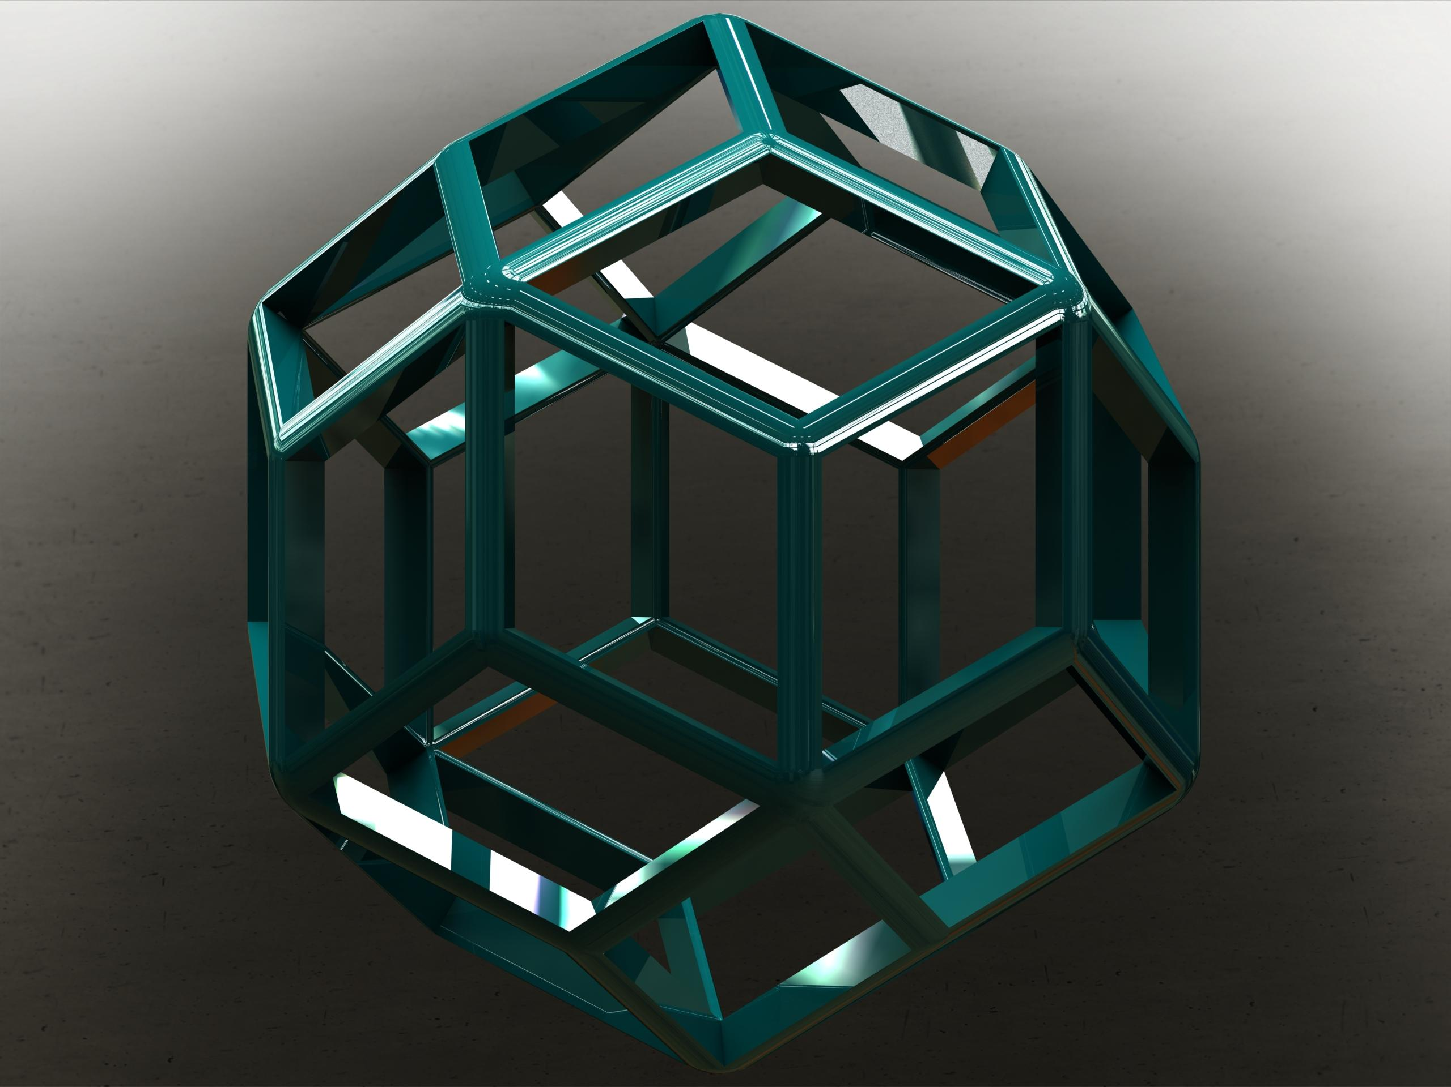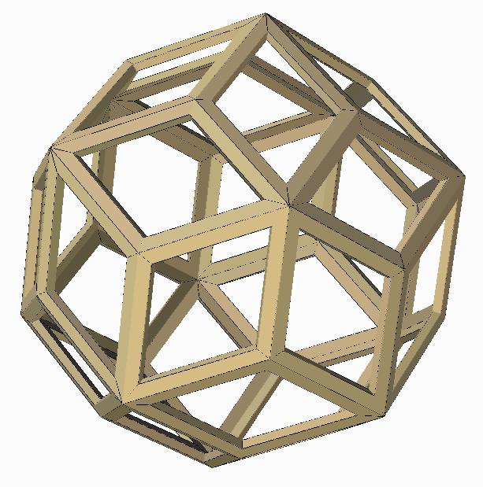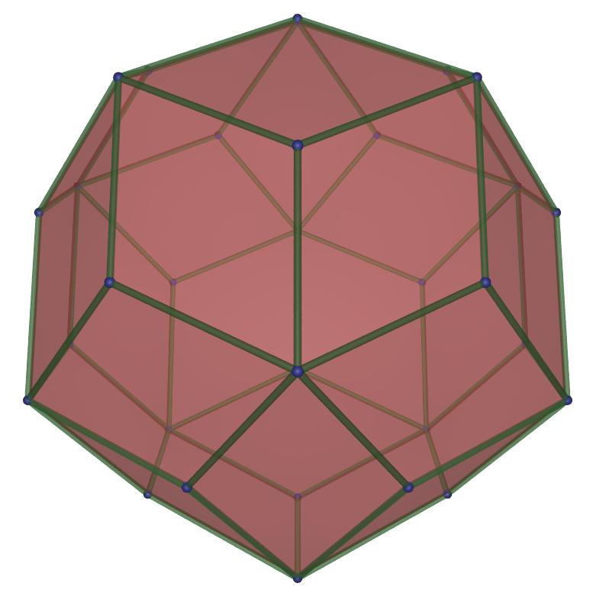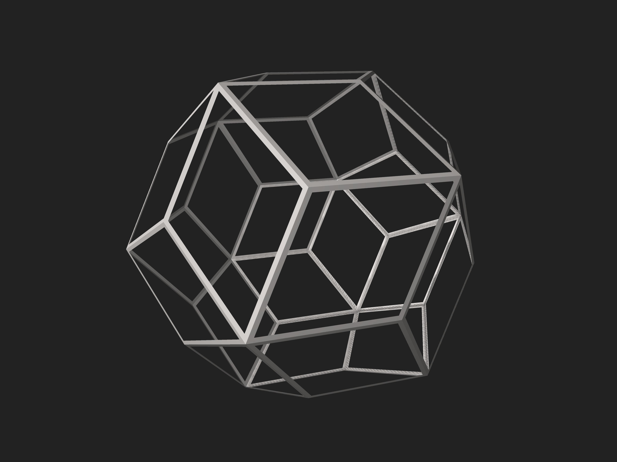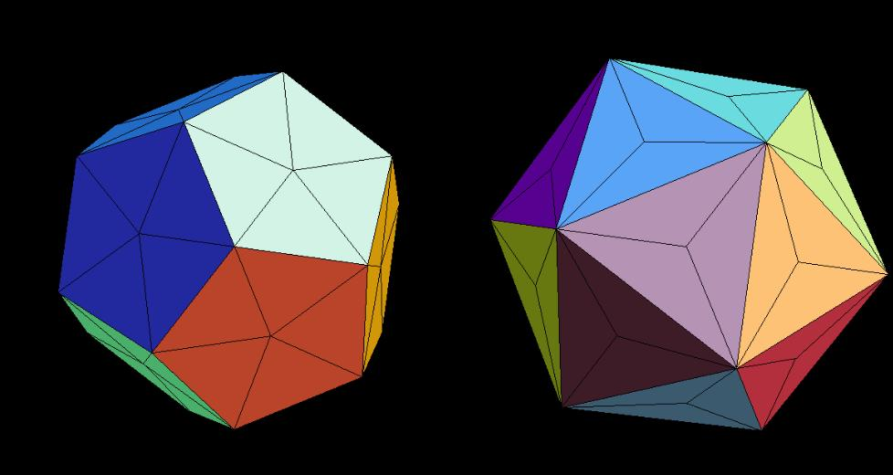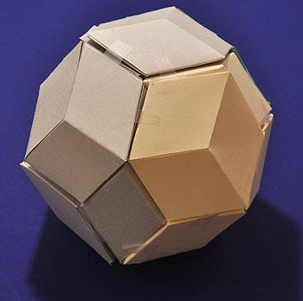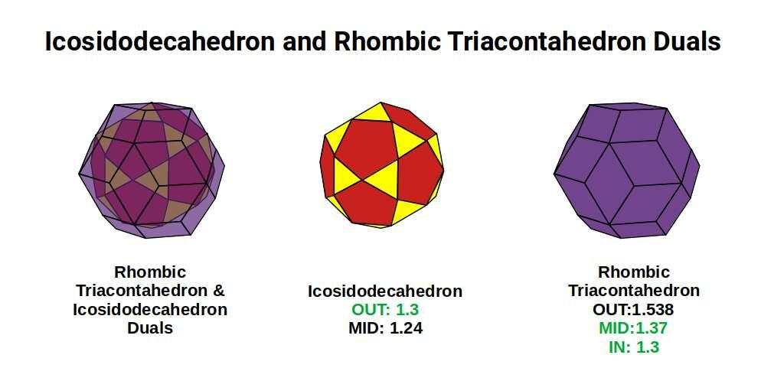

Geometric Structure
# Source: AI Source: Provided by: [Data Path: Persons Table -> ID Column: 1, Name_En Column: Motasem Essam] -> From: [ChatGPT] on [7/25/2026]
- It is a convex polyhedron.
- It has 30 congruent rhombic faces.
- It has 60 edges.
- It has 32 vertices.
- All 30 faces have the same shape and size.
- It has two different vertex configurations.
- It has full icosahedral symmetry.
The Rhombic Triacontahedron is a face-transitive solid, meaning that every face can be mapped onto any other face by a symmetry of the solid.

Face Structure
# Source: AI Source: Provided by: [Data Path: Persons Table -> ID Column: 1, Name_En Column: Motasem Essam] -> From: [ChatGPT] on [7/25/2026]
The Rhombic Triacontahedron has 30 congruent golden rhombuses.
A golden rhombus is a rhombus whose diagonal lengths are in the golden ratio.
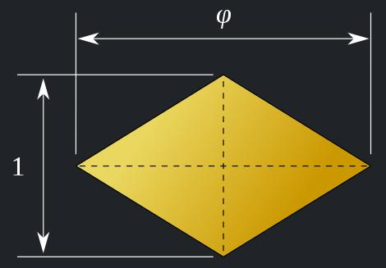
Each face has:
- Four equal sides.
- Two pairs of parallel opposite sides.
- One acute angle and one obtuse angle.
- A long diagonal and a short diagonal.

Face angles
# Source: AI Source: Provided by: [Data Path: Persons Table -> ID Column: 1, Name_En Column: Motasem Essam] -> From: [ChatGPT] on [7/25/2026]
The acute angle is approximately:
$$α={63.435}^{°}$$
The obtuse angle is approximately:
$$β={116.565}^{°}$$
Since opposite angles are equal, each rhombus has two acute angles and two obtuse angles.

Golden ratio
# Source: AI Source: Provided by: [Data Path: Persons Table -> ID Column: 1, Name_En Column: Motasem Essam] -> From: [ChatGPT] on [7/25/2026]
The ratio of the long diagonal $D$ to the short diagonal $d$ is:
$$\frac{D}{d}=φ$$
Where:
$$φ=\frac{1+\sqrt{5}}{2}≈1.618$$
This special proportion is what makes each face a golden rhombus.

Edge Structure
# Source: AI Source: Provided by: [Data Path: Persons Table -> ID Column: 1, Name_En Column: Motasem Essam] -> From: [ChatGPT] on [7/25/2026]
The Rhombic Triacontahedron has 60 equal-length edges.
Unlike many other Catalan solids, it has only one edge length because it is the dual of the quasi-regular Icosidodecahedron.
- Total edges: 60.
- All edges have the same length.
- Every edge is shared by exactly two rhombic faces.

Vertex Structure
# Source: AI Source: Provided by: [Data Path: Persons Table -> ID Column: 1, Name_En Column: Motasem Essam] -> From: [ChatGPT] on [7/25/2026]
The Rhombic Triacontahedron has 32 vertices, divided into two groups:
- 20 vertices of degree 3: Three rhombic faces meet at each vertex.
- 12 vertices of degree 5: Five rhombic faces meet at each vertex.
The two vertex groups correspond to the vertices of an inscribed icosahedron and dodecahedron, respectively.

Mathematical Properties
# Source: AI Source: Provided by: [Data Path: Persons Table -> ID Column: 1, Name_En Column: Motasem Essam] -> From: [ChatGPT] on [7/25/2026]
30
Faces
60
Edges
32
Vertices
144°
Dihedral angle
Euler's formula
$$V-E+F=2$$
$$32-60+30=2$$
The Rhombic Triacontahedron satisfies Euler's polyhedron formula.

Face diagonal relationship
# Source: AI Source: Provided by: [Data Path: Persons Table -> ID Column: 1, Name_En Column: Motasem Essam] -> From: [ChatGPT] on [7/25/2026]
$$\frac{D}{d}=\frac{1+\sqrt{5}}{2}$$
The long and short diagonals of every face follow the golden ratio.

Surface area
# Source: AI Source: Provided by: [Data Path: Persons Table -> ID Column: 1, Name_En Column: Motasem Essam] -> From: [ChatGPT] on [7/25/2026]
Let $a$ represent the common edge length of the rhombuses.
The area of one rhombic face is:
$$A_{f}=a^{2}sin({63.435}^{°})$$
Therefore, the total surface area is:
$$SA=30a^{2}sin({63.435}^{°})$$
Simplifying:
$$\boxed{SA=12\sqrt{5} a^{2}}$$

Volume
# Source: AI Source: Provided by: [Data Path: Persons Table -> ID Column: 1, Name_En Column: Motasem Essam] -> From: [ChatGPT] on [7/25/2026]
The volume depends on the edge length. For a model whose dual Icosidodecahedron has unit edge length, the Rhombic Triacontahedron has volume approximately:
$$V≈14.8002$$

Symmetry
# Source: AI Source: Provided by: [Data Path: Persons Table -> ID Column: 1, Name_En Column: Motasem Essam] -> From: [ChatGPT] on [7/25/2026]
The Rhombic Triacontahedron has full icosahedral symmetry, represented by the symmetry group:
$$I_{h}$$
Its symmetry includes:
- Five-fold rotational axes.
- Three-fold rotational axes.
- Two-fold rotational axes.
- Reflection planes.
- Central inversion symmetry.
It is face-transitive and edge-transitive, meaning all faces are equivalent under symmetry and all edges can be mapped onto one another. However, it is not vertex-transitive because it has two different vertex configurations.

Relationship to Other Solids

Dual: Icosidodecahedron
# Source: AI Source: Provided by: [Data Path: Persons Table -> ID Column: 1, Name_En Column: Motasem Essam] -> From: [ChatGPT] on [7/25/2026]
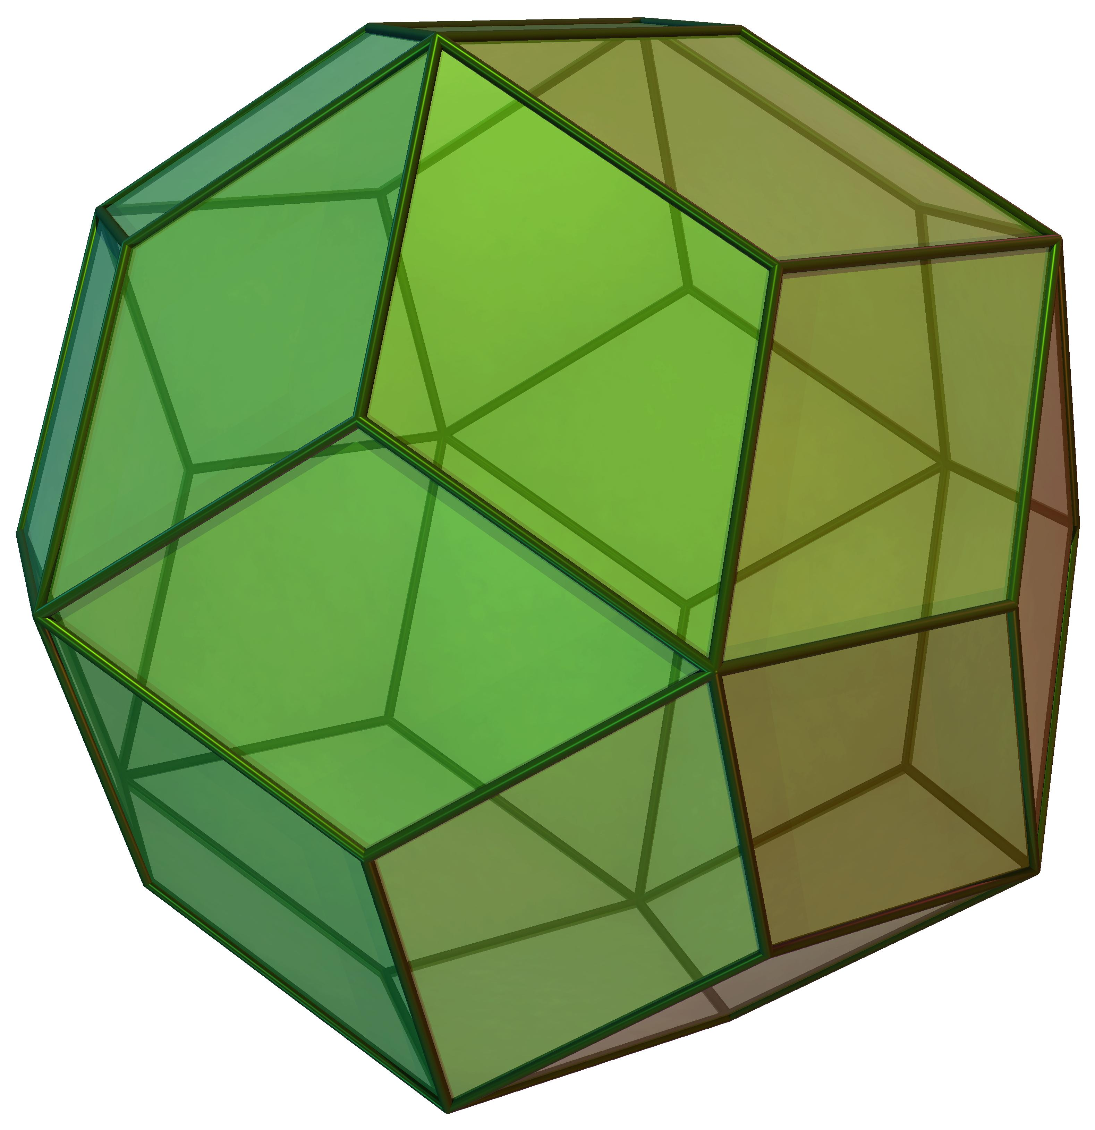
Rhombic Triacontahedron
Catalan solid
<icon name="arrow-left-right" size="xl"/>
Duality
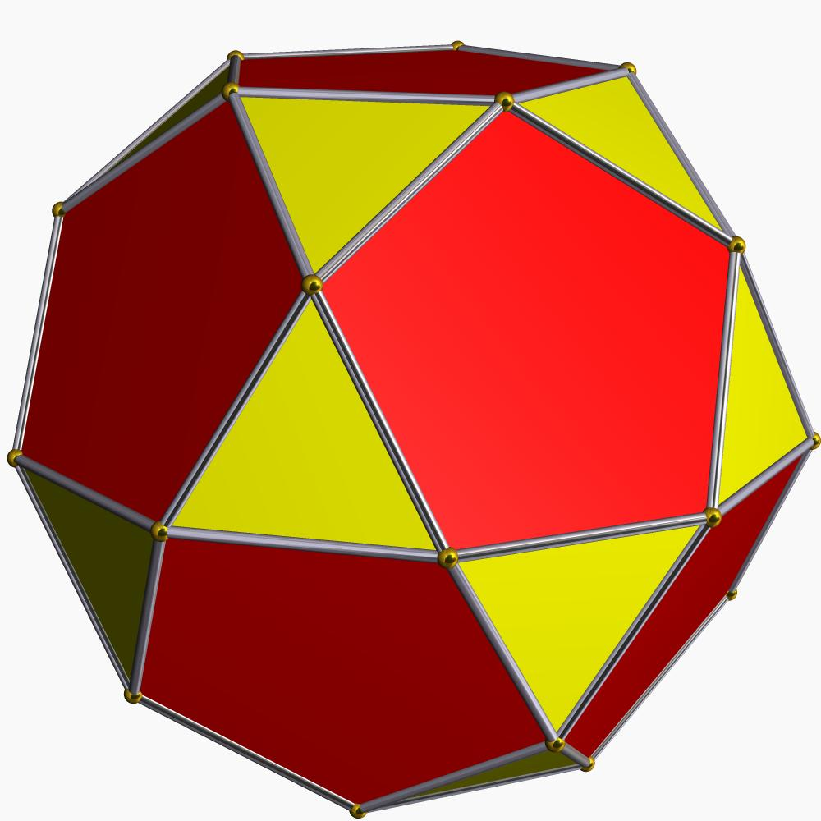
Icosidodecahedron
Archimedean solid
The Rhombic Triacontahedron is the dual of the Icosidodecahedron.
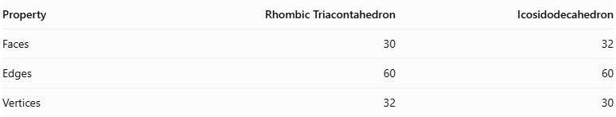
Property | Rhombic Triacontahedron | Icosidodecahedron
Faces | 30 | 32
Edges | 60 | 60
Vertices | 32 | 30
In polyhedral duality:
- Each face of the Rhombic Triacontahedron corresponds to a vertex of the Icosidodecahedron.
- Each vertex of the Rhombic Triacontahedron corresponds to a face of the Icosidodecahedron.
- Their edges correspond to each other.

Constructing a Rhombic Triacontahedron

Geometric Instruments Used
# Source: AI Source: Provided by: [Data Path: Persons Table -> ID Column: 1, Name_En Column: Motasem Essam] -> From: [ChatGPT] on [7/25/2026]
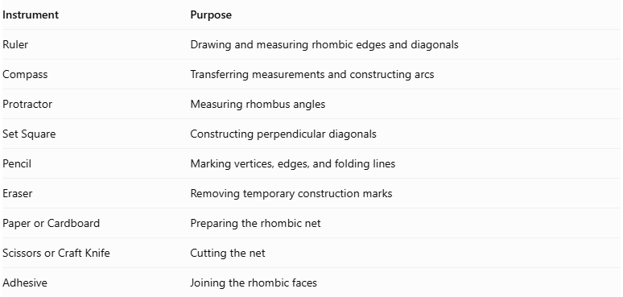
Instrument | Purpose
Ruler | Drawing and measuring rhombic edges and diagonals
Compass | Transferring measurements and constructing arcs
Protractor | Measuring rhombus angles
Set Square | Constructing perpendicular diagonals
Pencil | Marking vertices, edges, and folding lines
Eraser | Removing temporary construction marks
Paper or Cardboard | Preparing the rhombic net
Scissors or Craft Knife | Cutting the net
Adhesive | Joining the rhombic faces

Instrument-Based Construction Procedures

Method 1: Construction Using a Golden Rhombic Net
# Source: AI Source: Provided by: [Data Path: Persons Table -> ID Column: 1, Name_En Column: Motasem Essam] -> From: [ChatGPT] on [7/25/2026]
Step 1: Determine the Golden Ratio
The Golden Ratio is:
$$φ=\frac{1+\sqrt{5}}{2}$$
$$φ≈1.618034$$
The long diagonal $D_{L}$ and short diagonal $D_{S}$ of each rhombic face must satisfy:
$$\frac{D_{L}}{D_{S}}=φ$$
Therefore:
$$D_{L}=φD_{S}$$
Step 2: Construct the First Golden Rhombus
- Draw the long diagonal using a ruler.
- Mark its midpoint.
- Construct a perpendicular line through the midpoint.
- Determine the short diagonal using the Golden Ratio.
- Mark half of the short diagonal on both sides of the midpoint.
- Connect the four endpoints to form a rhombus.
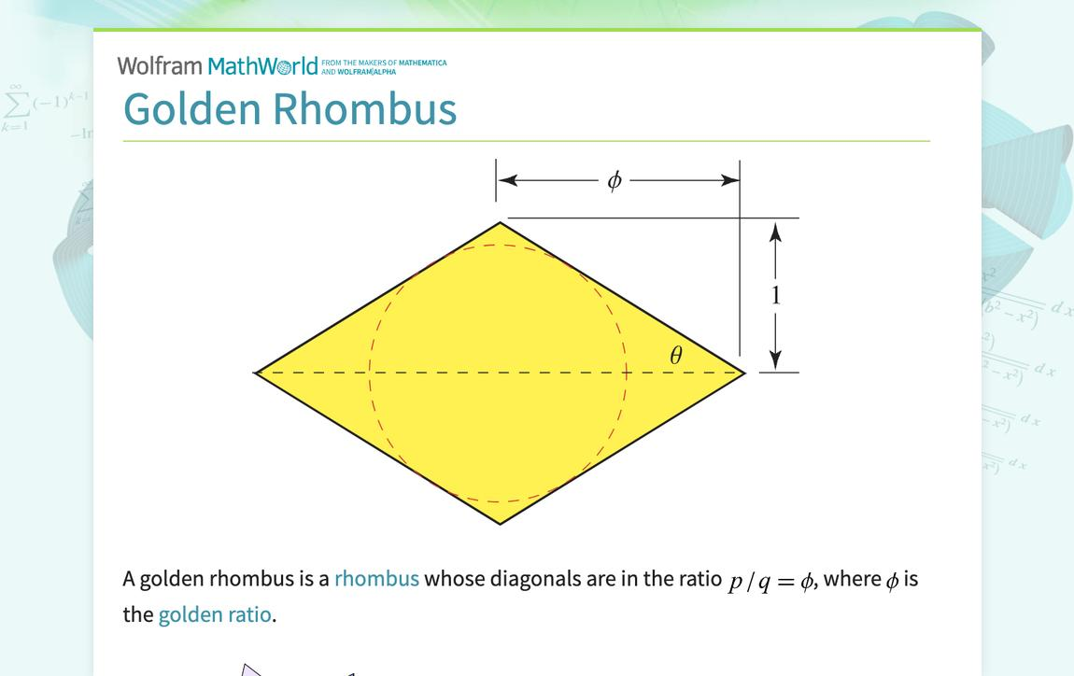
Step 3: Verify the Rhombus Angles
The two interior angles of the golden rhombus are:
- Acute angle: approximately ${63.435}^{°}$.
- Obtuse angle: approximately ${116.565}^{°}$.
Use a protractor to verify the angles.
Step 4: Construct the Remaining Rhombi
- Construct 29 additional golden rhombi.
- Maintain the same diagonal ratio.
- Ensure that all 30 rhombi are congruent.
- Verify that all edges have equal lengths.
Step 5: Arrange the Rhombic Faces
- Arrange the 30 rhombi according to a valid Rhombic Triacontahedron net.
- Maintain the correct edge-to-edge connections.
- Organize the net so that the resulting solid has 20 trivalent vertices and 12 five-valent vertices.
- Add joining tabs along selected outer edges.
Step 6: Cut Out the Net
- Cut around the outer boundary.
- Preserve the joining tabs.
- Avoid cutting along the internal folding lines.
Step 7: Fold the Rhombic Faces
- Fold along the shared edges.
- Raise the rhombic faces gradually.
- Bring the corresponding edges together.
- Maintain the correct orientation of the acute and obtuse corners.
Step 8: Join the Faces
- Apply adhesive to the joining tabs.
- Connect the corresponding edges.
- Allow the structure to hold its three-dimensional shape.
Step 9: Complete the Solid
Verify the finished model:
- 30 rhombic faces.
- 60 edges.
- 32 vertices.
- 20 trivalent vertices.
- 12 five-valent vertices.
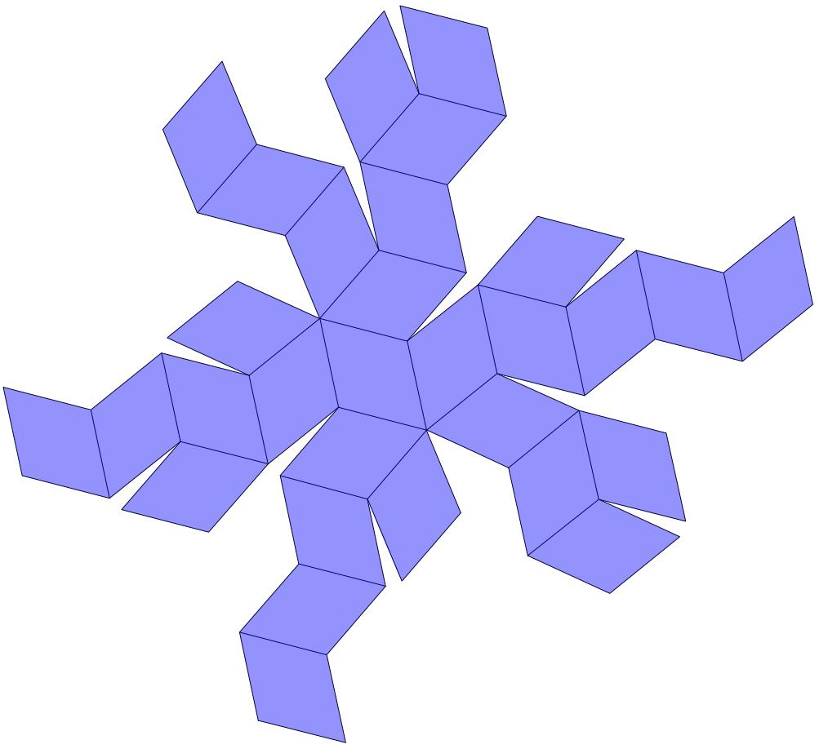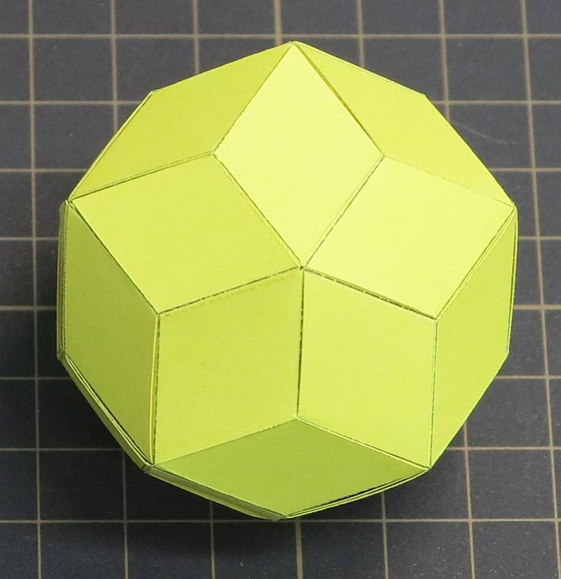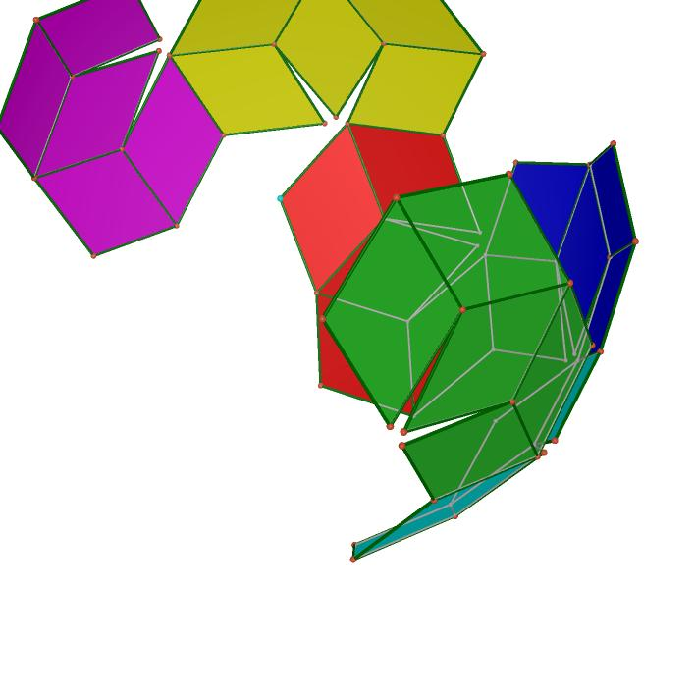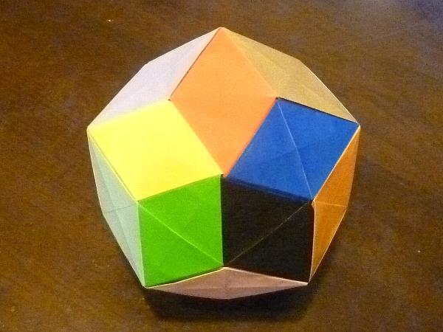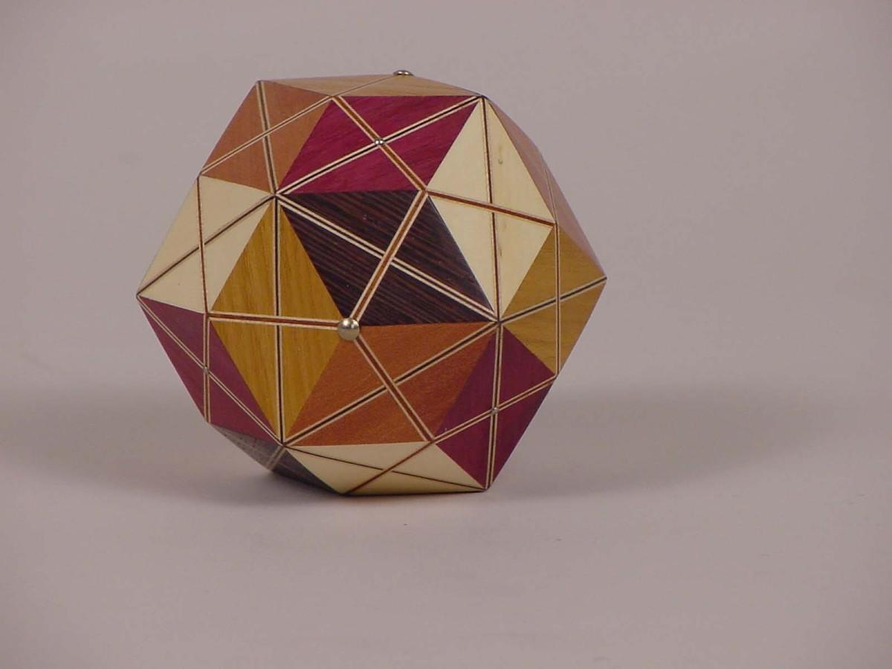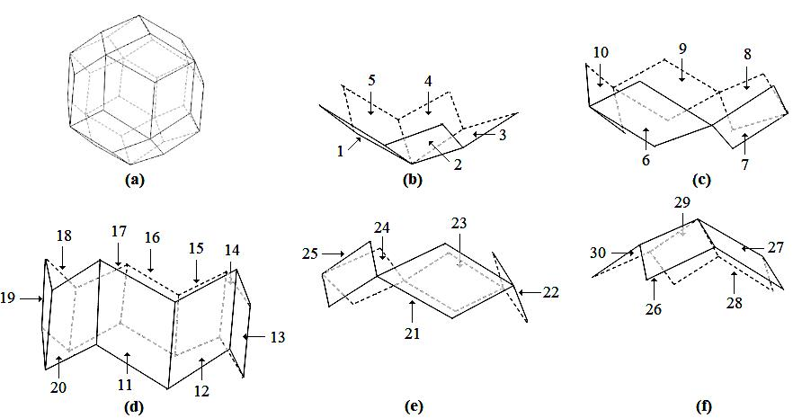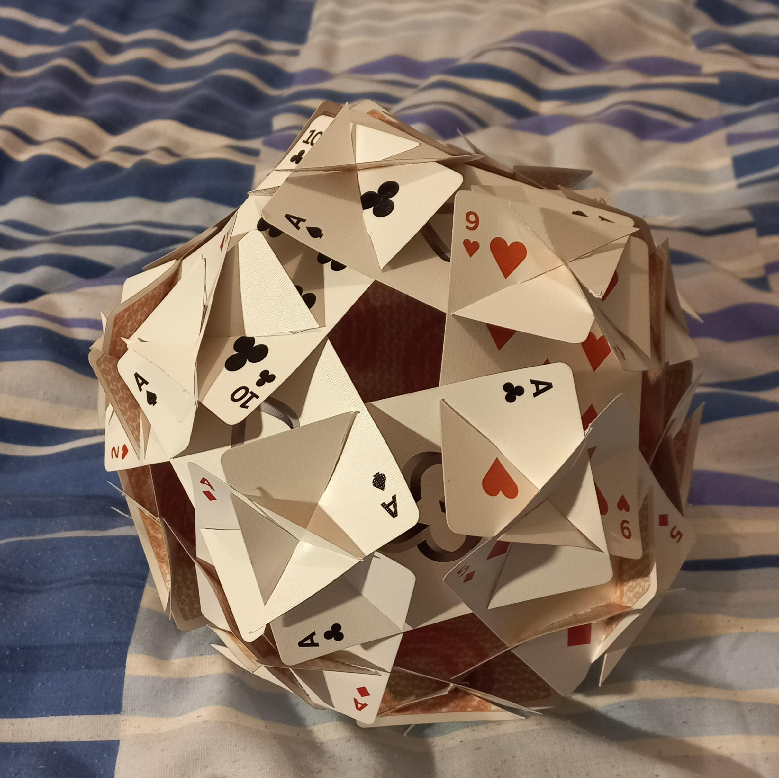

Method 2: Construction Using Two Bowl-Shaped Parts and a Ring
# Source: AI Source: Provided by: [Data Path: Persons Table -> ID Column: 1, Name_En Column: Motasem Essam] -> From: [ChatGPT] on [7/25/2026]
This method constructs the solid from three assembled sections.
Step 1: Prepare the Golden Rhombi
- Construct 30 identical golden rhombi.
- Verify their diagonal ratio and equal edge lengths.
Step 2: Construct the First Bowl-Shaped Section
- Arrange 10 rhombi into a connected bowl-shaped component.
- Fold the rhombi along their shared edges.
- Join the corresponding outer edges.
Step 3: Construct the Second Bowl-Shaped Section
- Repeat the process using another 10 golden rhombi.
- Ensure that the second bowl has the same dimensions as the first.
Step 4: Construct the Ring-Shaped Section
- Arrange the remaining 10 rhombi into a ring-shaped component.
- Connect the rhombi along their matching edges.
- Check that the ring can join both bowl-shaped sections.
Step 5: Assemble the Three Sections
- Attach the first bowl to one side of the ring.
- Attach the second bowl to the opposite side.
- Join all corresponding edges.
Step 6: Complete the Solid
- Check that the three sections form one closed polyhedron.
- Verify that all 30 rhombic faces are connected correctly.
- Confirm the final vertex and edge counts.
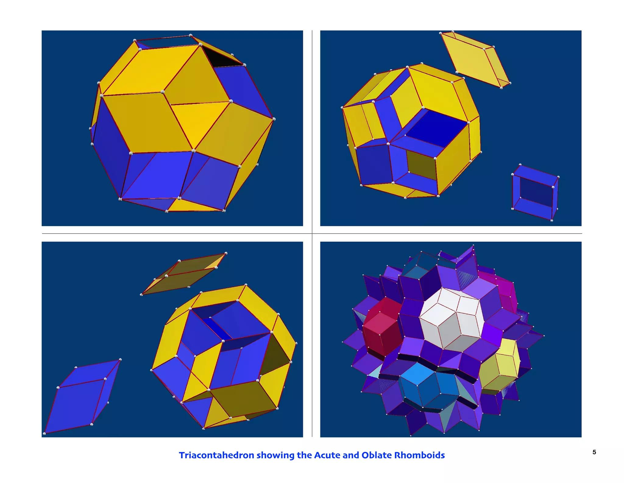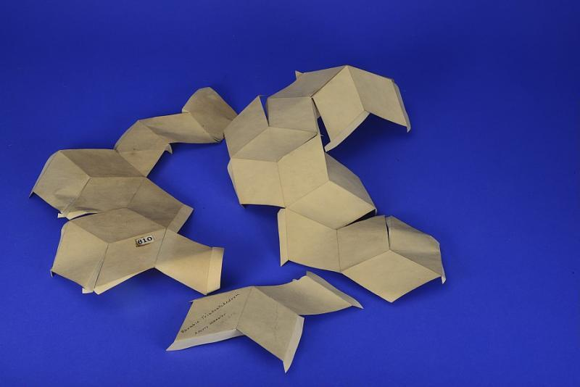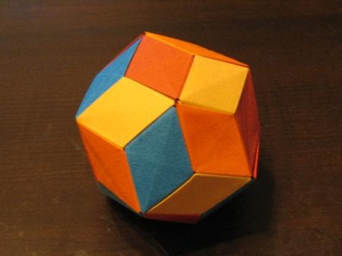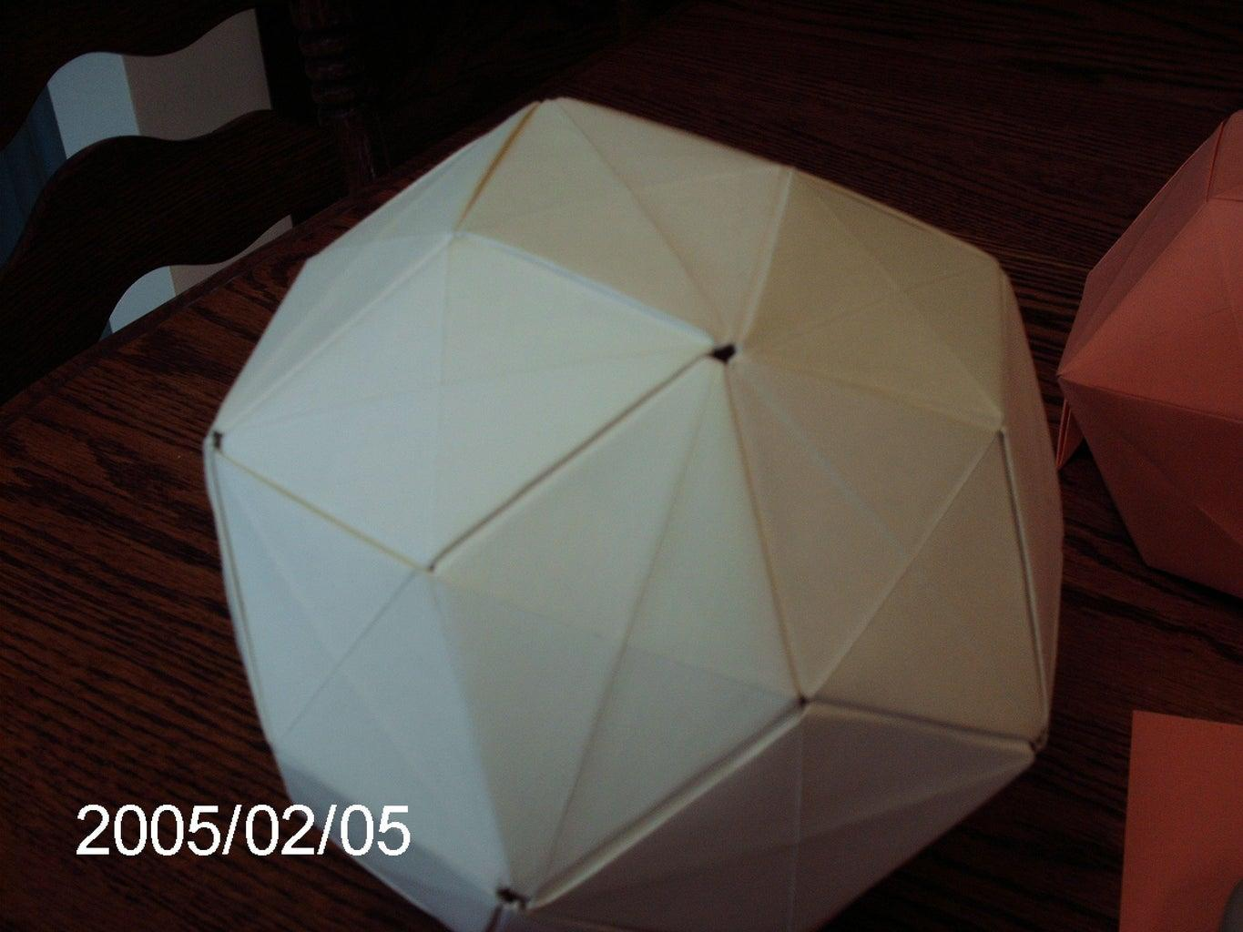
This three-section assembly method is documented in the paper-model construction instructions from Had2Know.

Method 3: Construction Using the Dual of an Icosidodecahedron
# Source: AI Source: Provided by: [Data Path: Persons Table -> ID Column: 1, Name_En Column: Motasem Essam] -> From: [ChatGPT] on [7/25/2026]
This method uses the dual relationship between the Icosidodecahedron and the Rhombic Triacontahedron.
Step 1: Construct the Icosidodecahedron
- Prepare a reference model of an Icosidodecahedron.
- Identify its 20 triangular faces and 12 pentagonal faces.
- Verify its 30 vertices and 60 edges.
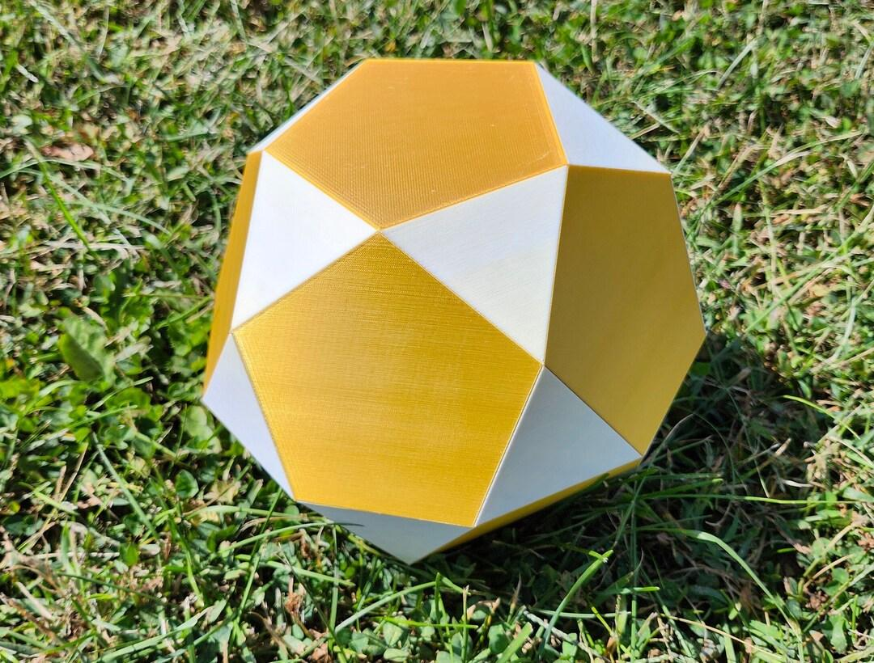
Step 2: Identify the Face Centers
- Mark the center of each triangular and pentagonal face.
- Identify the perpendicular direction from each face center.
- Use the face centers as references for constructing the dual vertices.
Step 3: Establish the Dual Vertices
- Construct one dual vertex for each original face.
- Position the dual vertices using the appropriate polar-dual construction.
- Maintain the symmetry and proportions required for the standard Rhombic Triacontahedron.
Step 4: Identify the Original Vertices
- Examine the 30 original vertices.
- Identify the faces meeting at each vertex.
- Each original vertex corresponds to one rhombic face in the dual.
Step 5: Connect the Dual Vertices
- Connect the dual vertices associated with the faces surrounding each original vertex.
- Form one rhombic face for each original vertex.
- Repeat until all 30 rhombi are constructed.
Step 6: Complete the Dual Structure
- Verify the 30 rhombic faces.
- Check the 60 edges and 32 vertices.
- Confirm that all faces are congruent golden rhombi.
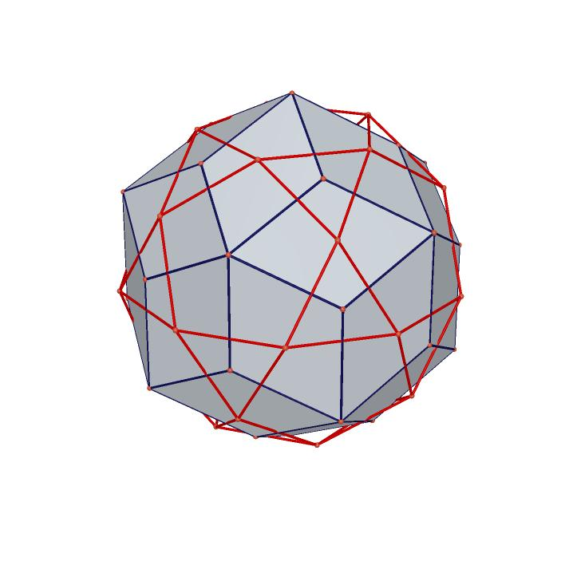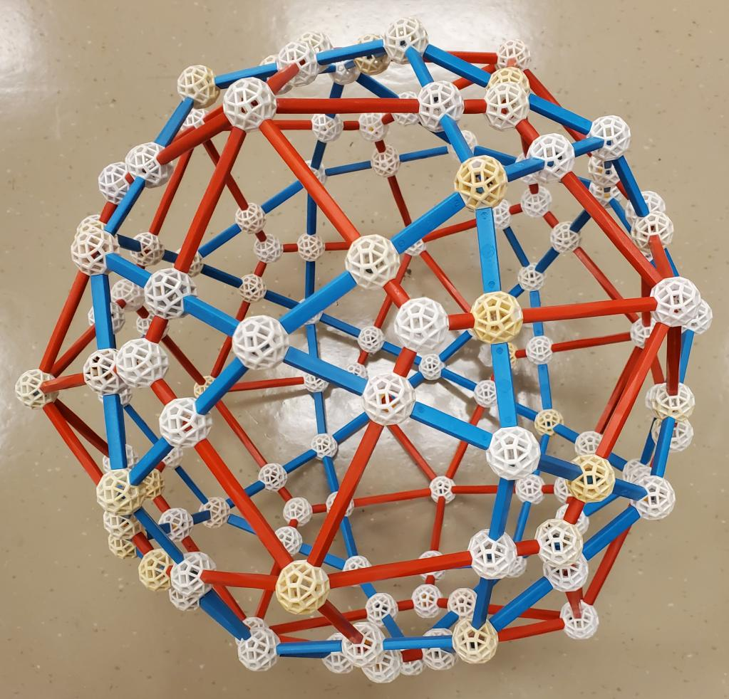
Important: Simply connecting ordinary face centers does not necessarily produce the standard Rhombic Triacontahedron. The dual vertices must be positioned using the appropriate polar-dual construction.

Key Points
# Source: AI Source: Provided by: [Data Path: Persons Table -> ID Column: 1, Name_En Column: Motasem Essam] -> From: [ChatGPT] on [7/25/2026]
- The Rhombic Triacontahedron is a Catalan solid.
- It has 30 congruent golden rhombic faces.
- It has 60 equal-length edges.
- It has 32 vertices.
- Its vertices have two configurations: degree 3 and degree 5.
- Its face diagonals follow the golden ratio.
- It is the dual of the Icosidodecahedron.
- It has full icosahedral symmetry $I_{h}$.
- It is convex, face-transitive, and edge-transitive.

Conclusion
# Source: AI Source: Provided by: [Data Path: Persons Table -> ID Column: 1, Name_En Column: Motasem Essam] -> From: [ChatGPT] on [7/25/2026]
The Rhombic Triacontahedron is a distinctive member of the Catalan solids family. Its 30 golden rhombic faces, 60 equal edges, and two types of vertices give it a special geometric structure. Its golden-ratio proportions and dual relationship with the Icosidodecahedron make it an important example of polyhedral geometry and symmetry.

